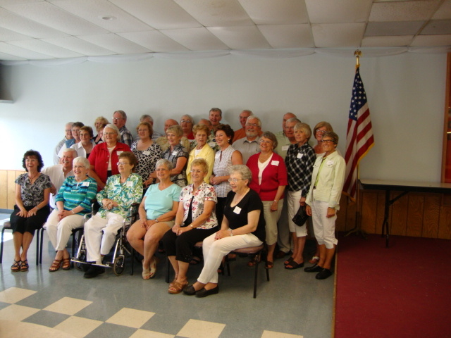

Class Picture Names

Sitting: Carol(Johnson) O’Reilly Lucille (Lohmann) Jacobs LaVonne (Stechmann) Albrecht Judy (Olson) Perry Anne (Mercier) Williamson Pauline (Friese) Jagusch

Kneeling: Norris Nordvold

Next Row: Sandra (Collinge) Paul Luana (Erickson) Skibiel Janelle (Hoven) Clark Roxann (Berg) Bonde Rose (Hamm) Barry

Next Row: Judy (Matthees) Stern Sylvia (Betcher) Hoffman Judy (Trelstad) Lang Aurilla (Klug) Maas Gary Birmingham Bruce Henning Philip Aaland Charles Schulz Suzy Hoven Bonnie (Tilbury) Toppings Barb (Kruse) Paulsen

Back Row: Ann (Jossens) Steege Barbara (Tuve) Crockett Craig Satrum Gerald Torvund Barbara (Koester) Budensiek Keith Clementson David Schleicher Ralph Stehr

Then on Sunday Don Swenson attended.

Total - 31 Classmates Attended

